**Lab Task 4: Write a program to convert following code into assembly program.**

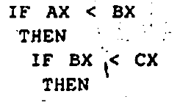

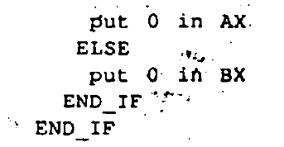

org 100h

mov ax, 33h

mov bx, 35h

mov cx, 37h

cmp ax, bx

jl if

mov dl, 30h

mov ah, 2

int 21h

jmp exit

if:

cmp bx, cx

mov dl, 31h

mov ah, 2

int 21h

jmp exit

exit:

mov ah, 4ch

int 21h

ret

**Lab task 5: Write a program to convert following code into assembly program.**

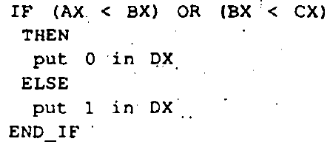

org 100h

mov ax, 34h

mov bx, 32h

mov cx, 39h

cmp ax, bx

jge if

cmp bx, cx

mov dx, 30h

mov ah, 2

int 21h

jmp exit

if:

mov dx, 31h

mov ah, 2

int 21h

jmp exit

exit:

mov ah, 4ch

int 21h

ret

**Lab task 6: Write a program to convert following code into assembly program**

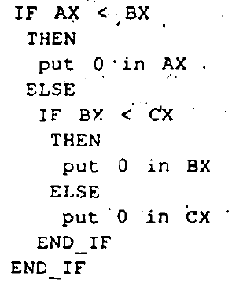

org 100h

mov ax, 03h

mov bx, 02h

mov cx, 05h

cmp ax, bx

jl if

jmp else

jmp if_if

jmp if_else

if:

mov ax, 30h

jmp exit

else:

cmp bx, cx

jl if_if

jmp if_else

if_if:

mov bx, 30h

jmp exit

if_else:

mov cx, 30h

jmp exit

exit:

mov ah, 4ch

int 21h

ret